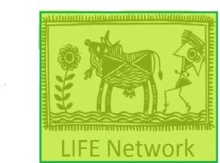
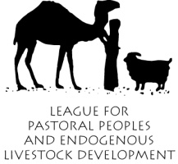
LPP, LIFE Network, CELEP Statement in Plenary during CoAg, 22nd May, 2012
Thank you Chair,
I am speaking on behalf of the League for Pastoral Peoples and Endogenous Livestock Development as well as the LIFE Network, and in alliance with CELEP (Coalition of European Lobbies for East African Pastoralism) and would like to congratulate FAO on initiating the Global Agenda of Action in support of sustainable livestock sector development. We are convinced that such an initiative is sorely needed in order to put global livestock sector development on a sustainable trajectory – something that is currently not the case. While we have the highest appreciation for the participatory and multi stakeholder nature in which the GAA has been designed and in which the preparatory meetings have been implemented, we feel that significant value could be added to the initiative by addressing the following three points:
- Emphasis must be placed on the investigation of viable and sustainable alternatives to the high input model of livestock production that is exemplified by the Livestock Revolution and that depends on a very narrow range of animal genetic resources, as well as soy, corn, chemical fertilizer, herbicides, antibiotics, feed additives and oil. The global proliferation of this production model is in conflict with several legally binding international agreements, such as the UN Convention on Biological Diversity (CBD), the UN Convention on Combating Desertification (UNCCD), and others. Alternatives to the high-input systems would consist of increasing the output of the decentralised livestock production systems in the world’s marginal areas by means of the provision of services and creation of a level playing field with the high input systems. These systems make a huge contribution to national and regional economies in addition to sustaining millions of producers directly, for instance in East Africa, they feed 25 million people, produce 80% of the total annual milk supply in Ethiopia and provide 90% of the meat consumed in EA. In India and Pakistan, they produce practically all non-poultry meat. They are achieving this with very little public investment and in the face of a hostile policy environment. With appropriate investment and in a supportive policy environment, output could be significantly improved. By making better use of biomass in a biodiversity sustaining manner, such an approach would significantly contribute to the fulfilment of several of the UN Millennium Goals, by directing resources towards the 600 million poor people in the world that depend on livestock for their livelihoods.
- This brings us to the second point: There is evidence that the Livestock Revolution has had significant negative effects in terms of rural development and poverty alleviation, as compiled in a recent study by LPP entitled “Livestock out of balance”. In particular it runs counter to the potential of livestock development to lift people out of poverty. Since the aforementioned 600 million poor people worldwide that depend on livestock for their livelihoods, arguably represent the largest stakeholder group in the GAA, it is essential that a mechanism is set up for their effective and genuine participation in the GAA. This would include financing, capacity-building and development of a two way line of communication between these groups and the GAA secretariat, as well as policy makers in general.
- Finally, we should revisit some of the recommendations and conclusions of the CoAg Session in 2010 and check whether the current constellation of the global dialogue corresponds to the then stated need to “address in a balanced and holistic manner the complex social, economic and environmental issues and trade-offs associated with the sector”, as the emphasis of the current initiative is focused on environmental issues alone.

