Projecting Pastoralism as a productive and ecological livestock system for the future II
The overall goal of this follow-up project that is supported by Misereor is to institutionalize mechanisms and policies that give greater weight to pastoralism in the agro-ecological transformation of the global food sector.
Through the project LPP will support advocacy and capacity building of pastoralist communities with respect to assessments of their numerical, economic and ecological importance.
LPP will provide inputs to the policy debate around the ‘detrimental effects’ of livestock through blogs, responses to misleading information and articles.
The project shall mainstream the concept of pastoralism /mobile livestock keeping among various movements/platforms, including in Europe/Germany.
One of the project activities is the development of a World map of Pastoralists:
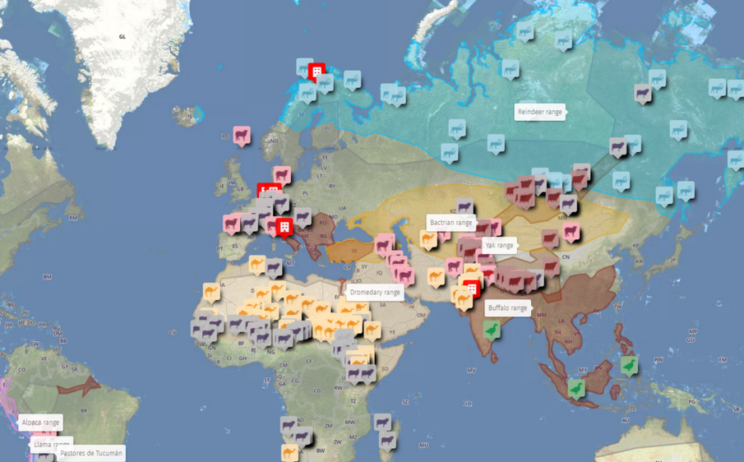
With the map we want to show the extent of nature-positive livestock production throughout the world. Pastoralism is a big part of this.
The map is not yet complete. It is an ongoing project that should be constantly added to and corrected.

